VSEPR and Predicting Molecular Geometry
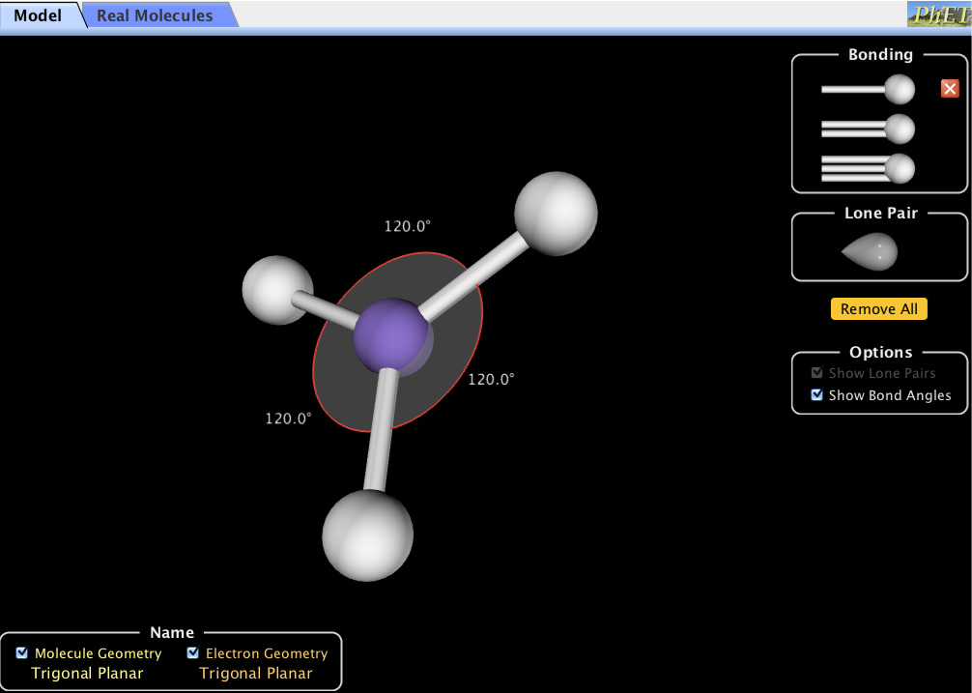
Once we have the Lewis structure, we have the information needed to predict the geometry. It’s important to remember that what we really want to know is the molecular geometry—the positions of the nuclei in relation to each other. The molecular geometry is dependent on the electron domain geometry; that is why the initial step is drawing the appropriate Lewis structure! As noted above, the simple concept behind valence shell electron pair repulsion theory (VSEPR) is the idea that electron pairs in the valence shell of an atom will repel each other and arrange themselves as far apart as possible. This arrangement of electron pairs will determine the geometry of the molecule or polyatomic ion.
Your initial task in this activity is to determine the molecule geometry as the number of electron pairs changes. Accomplish this by using the computer simulation “Molecule Shapes” (shown at left) and fill in the table.
Notice, in this simulation you can increase the number of electron domains by adding single, double, or triple bonds, or lone pair electrons. In the lower left corner you will find both the molecule geometry and the electron geometry.

Figure 1. The PhET Computer Simulation “Molecule Shapes”.
Table 2. Model Electron Domain Geometries.
Number of Electron Domains | Electron Domain Geometry | Bond Angles
2 | Linear | 180o
3
4
5
6

The molecular geometry is the same as the electron domain geometry if all domains contain bonding pairs. What if lone pair electrons are present on the central atom? The molecular geometry will NOT be the same as the electron domain geometry. To investigate this, return to the simulation and com- plete Table 3. If you do not understand the names for the different geometries ask your Teaching As- sistant.
Table 3. Electron and Molecular Geometries.
Number of electron domains | Bonding Pairs | Nonbonding Pairs | Electron Domain Geometry | Molecular Geometry
2 | 2 | 0
3 | 3 | 0
3 | 2 | 1
4 | 4 | 0
4 | 3 | 1
4 | 2 | 2
5 | 5 | 0
5 | 4 | 1
5 | 3 | 2
5 | 2 | 3
6 | 6 | 0
6 | 5 | 1
6 | 4 | 2

Question 1. VSEPR standards for “valence-shell electron-pair repulsion”. How does electron pair repulsion determine the molecular geometry? Discuss two specific examples from the table. (Hint: In the simulation is it possible to force the electron domains to be close together?)

Question Set 2.
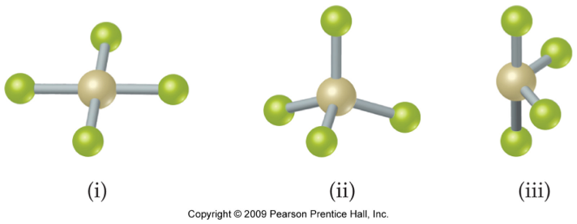
For each shape identify the molecular geometry.

i.
ii.
iii.
Determine the electron-domain geometry on which the molecular geometry is based.
Which of the following element(s) could be the central atom in
i. shape (iii)?
Be, C, S, Se, Si, Xe?
ii.
iii.
How many lone-pairs are there on each central atom?
i.
ii.
iii.
You may have noticed that some electron domains appear larger than others. To investigate how this may affect the resulting molecular geometry, complete Table 4 and predict both the geometry and the bond angles. Then, compare your predictions with the experimental determined bond angles (as shown in the simulation under the tab “Real Molecules”).
Table 4. Comparison of Electron Domains.
Molecule | Lewis Structure | Predicted Molecular Geometry | Predicted Bond Angles | Experimentally determined bond angles
NH3
H2O
SO2
Question 3. Which assumption about the space occupied by nonbonding (lone pair) electron pairs is most consistent with the experimental bond angles: do nonbonding pairs occupy more, less, or the same amount of space as bonding pairs?

VSEPR & Polarity: Putting it together...
Being able to predict the polarity of a molecule is extremely important since many properties of molecules depend on whether they are polar or non-polar. Determining a molecule’s polarity is a multistep process:
Draw Lewis Structure
↓
Use VSEPR to determine molecular geometry
↓
Determine bond polarity (based on electronegativity differences)
↓
Determine molecular polarity based on bond dipoles & molecular geometry
For the following molecules complete this step-by-step process.
Molecule | Lewis Structure | Molecular Geometry | Is there a molecular dipole?  A molecular dipole indicates it is a polar molecule.
N2
H2O
BF3
HCN
CH2F2
* Make a prediction, and then check it in the “Real Molecules” section of the simulation.

